NCATD
North Carolina Association of Teen Democrats
Leadership Guidebook

Table of Contents

Letter from the Editor 2
About the NCATD 3
Starting a County Chapter 4
Contact Your County Party 4
Meet Your Adult Advisor 4
Publicize Your Chapter 4
Plan Your First Meeting 4
Hold Your First Meeting 5
After Your First Meeting 5
High School Chapters 5
Meeting and Event Ideas 6
NCATD Statewide Convention 8
NCATD Advocacy Day 9
Website Resources 10

Letter from the Editor

In 1962, Governor Terry Sanford first proposed the creation of a statewide organization for teen Democrats while he toured the state of North Carolina to promote racial integration in public schools. The first statewide convention of the North Carolina Association of Teen Democrats occurred on June 15, 1962 in Raleigh. Soon after, the organization elected its first president, a high school student named John Hughes from Jones County.
Since 1962, the North Carolina Association of Teen Democrats has expanded throughout our state, with active chapters ranging from Wilmington to Morganton and Waxhaw to Chapel Hill. As the oldest statewide organization for teen Democrats in the United States, the NCATD has been pivotal in establishing a nationwide presence for Democratic Party youth, with a president of the NCATD having founded the predecessor to today’s High School Democrats of America. Among the NCATD’s alumni include a former governor, two chairmen of the North Carolina Democratic Party, and dozens of statewide and local elected officials.
This guidebook contains information on the structure and procedures of the NCATD, strategies for creating and maintaining new chapters, and advice on how to expand chapter membership, plan events, hold meetings, and coordinate with fellow Democratic groups and causes. This guidebook should be used by elected NCATD officers, members interested in advancing their local chapters, and those who wish to create new chapters of the NCATD for their high school or county. It is our organization’s hope that through volunteering and activism within the Democratic Party, the vision for North Carolina that Governor Sanford set forth can one day be met.

Democratically yours,
Darren Janz
NCATD Vice President of Membership

About the NCATD

Since forming in 1962, The North Carolina Association of Teen Democrats has been officially recognized as the high school and teenage auxiliary of the North Carolina Democratic Party, the Young Democrats of North Carolina, and the College Democrats of North Carolina. To learn more about the organizations affiliated with the NCATD, click here. The NCATD is also an official chapter of the High School Democrats of America, a group that advocates for the interests of high school Democrats in all fifty states.

The North Carolina Association of Teen Democrats is governed by our Plan of Organization, a nineteen-page document that details the rules, policies, and procedures used for our organization. The Plan of Organization also contains sections establishing the mission and purposes of the NCATD.

The statewide leadership of the NCATD consists of an Executive Board and an Executive Council. The Executive Board, elected annually at our statewide convention (see page 8), consists of a President, an Executive Vice President, a Vice President of Membership, and a Vice President of Fundraising. The Executive Board is responsible for appointing members of the Executive Council, including a Communications Director, three regional directors, and a Secretary. Together, these two groups join the chairs of NCATD county chapters to form the NCATD Executive Committee.

The NCATD’s statewide leadership works closely with the adult advisor, who is appointed by the chairperson of the North Carolina Democratic Party to provide guidance and coordination for NCATD operations and activities. The adult advisor also chairs the Senior Advisory Board, a group of alumni and government officials that helps the NCATD raise funds and hold events.

The backbone of the NCATD, however, can be found on the local level, where high school and county chapters engage in activism and volunteering on a daily basis. The rest of this guidebook is dedicated to helping county chapter leaders - both current and aspiring - as they work to expand their chapters and fight for Democratic Party causes across North Carolina.

Starting a County Chapter

If your county doesn’t have an NCATD chapter, creating a county chapter is the best way to become involved. We recommend following these steps to start a new county chapter (remember to charter your chapter first):

- Contact Your County Party

Your new NCATD chapter will be part of your county’s Democratic Party. Find the contact information for your county party’s chair, and tell them about your interest in starting an NCATD chapter. Ask them when your county party meets, if they know any other active high school Democrats, and if they can help you find an adult advisor for your chapter. If you can’t get in touch with your county party, ask us for help.

- Meet Your Adult Advisor

Once you’ve found an adult advisor for your chapter, try to contact them. Your adult advisor can help you plan your first meeting and connect with other interested high school students. You and your adult advisor will share one vote on your county party’s Executive Committee. If your adult advisor already has a vote on your county party’s Executive Committee, you may be entitled to a full vote.

- Publicize Your Chapter

Talk about your chapter to students who may be interested from your high school, other high schools, and your extracurricular groups. Ask people from your county’s party if they know high school students who may be interested. Create social media accounts on Facebook, Twitter, and Instagram for your new chapter, and use them to advertise to high school students in your county. Facebook is especially useful in networking with members of your county party.

- Plan Your First Meeting

If many students already seem interested in joining, you may want to hold your meetings separately from your county party’s meetings. If only a few students seem interested so far, you may want to meet during your county party’s meetings. Either way, publicize the details of your meeting heavily through social media, conversations, and posters. Always mention your meeting’s time and location. Create a Facebook event for your meeting and share it to your county party’s page. Ask your friends to bring snacks, drinks, or other materials you may need.

- Hold Your First Meeting

Print our sign-in sheet and bring it to your meeting. Have each member introduce themselves and make a motion to pass your chapter bylaws. Discuss your chapter’s leadership positions and decide when elections will be held. Ask members what they want to do during meetings and what kind of volunteering and activities they want to participate in. Discuss your county party’s upcoming events, and ask your members when they would like to meet next. Most of all, have fun! Make sure your meeting is engaging so your members will be excited to continue.

- After Your First Meeting

Take a picture of your sign-in sheet and text it to (910)-599-3356 so we can keep a record of your chapter’s membership. Discuss your thoughts and plans with your adult advisor. Continue to publicize your chapter in person and through social media. Ask your members to help publicize your chapter so you can expand your network. Read the next page to learn about what you can do during your meetings and events.

- High School Chapters

Starting a chapter at your high school is a great way to get more students involved. To start a high school chapter, get permission from your school’s administration and find a teacher to serve as your advisor. If your school will not allow a club for Democrats, contact us for help or create a nonpartisan political club. Once you have permission and a teacher advisor, follow the same general steps listed above to publicize your chapter and hold meetings. Make sure to tell students from your high school chapter about your county chapter.

Meeting and Event Ideas

You may want to look at the ideas below to plan your chapter’s meetings and events. Feel free to use them or come up with your own.

- Invite a government official or Democratic candidate to speak to your chapter during a meeting or event. Most adults will be excited to speak with and listen to young people interested in the political process.
- Get your chapter to volunteer with a campaign. Many local campaigns offer internships and service hours to interested high school students. You will be able to participate in canvassing, phone banking, event planning, and communications. Make sure the candidates your chapter volunteers for have already been nominated by the Democratic Party.
- If there is an upcoming election for a major office, take a trip with your chapter to see a campaign event for one of the candidates. You will be able to see major figures in North Carolina and United States politics, and you may be able to meet a candidate in person if you ask ahead.
- Schedule your chapter to attend a meeting of your county commission, school board, or city council. This is a great way to learn more about local issues and meet your local government officials. Your members can also share their opinions on local issues with the officials present.
- Volunteer with a homeless shelter, a soup kitchen, a food pantry, an animal rescue shelter, or another local charitable organization. Philanthropic involvement is one of the NCATD’s six core purposes and can your chapter develop a good standing within your community.
- Host a debate on a political issue important to the members of your chapter. This is a good way to learn about different political perspectives within your chapter’s membership during one of your meetings.
- If there is an upcoming Democratic primary election, hold a mock straw poll or caucus during one of your meetings. Debate the reasons for and against supporting each candidate, and see which candidate wins.
- During the presidential campaign season, host a debate watch party. Provide snacks and drinks for the members present, and feel free to invite members of your county party’s other auxiliary groups.
- Dedicate a meeting to engaging in professional development exercises. Ask a professor, a business owner, or another adult to speak to your chapter about higher education and developing professional skills. You can also hold a resume writing workshop as part of your meeting.
- Schedule your chapter to attend a campaign training session. Session topics include campaign strategy, finance, and communications, and they are often held during election years at colleges and universities.
- Research proposed ballot initiatives in your community. If you find one that your chapter is passionate about, help collect signatures for the initiative so it appears on your city or county’s ballot in the next election.
- Organize a voter registration drive at a high school in your community. With the help of your county’s Democratic Party, you can register or pre-register high school students to vote if they are sixteen or older.
- Set up a table for your NCATD chapter at a club fair, a county fair, or another community event. Bring promotional materials (stickers, flyers, etc.) with you and advertise your chapter to your school or community.
- Host a barbecue, a pool party, or a similar event for your NCATD chapter. Invite your friends and members of your county’s Democratic Party to attend the event so you can have fun and promote your chapter.
- Attend the meetings and events hosted by your county’s Democratic Party and its auxiliary groups. This is the best opportunity for members of your NCATD chapter to network with fellow Democrats and become more involved in your county’s Democratic Party community.
- Sign up to attend the North Carolina Democratic Party’s Unity Dinner. The Unity Dinner, formerly known as the Jefferson-Jackson Dinner, is held every summer as an annual gathering of Democrats from across North Carolina. The dinner is typically followed by an After Dark event hosted by the Young Democrats of North Carolina.
- Bring your chapter to the annual events hosted by the NCATD, including our statewide convention in the spring and our Advocacy Day in the fall. To learn more about these events, go to pages 8 and 9.
- Whatever you do, remember to have fun! Make sure your meetings and events are engaging so members will be excited to return for more.

NCATD Statewide Convention

Every spring, the North Carolina Association of Teen Democrats holds its annual statewide convention, organized in conjunction with the annual statewide conventions of the Young Democrats of North Carolina and the College Democrats of North Carolina. The convention, typically held in late March or early April, is a great opportunity to meet and interact with teen Democrats from around North Carolina. The convention’s location is typically decided by the YDNC Executive Board a few months before it occurs.

Events typically held during the NCATD Statewide Convention include:

- The YDNC-CDNC-NCATD Networking Event
This is a great opportunity for teen Democrats to learn more about the CDNC and the YDNC, as well as to talk to and connect with young Democrats and college Democrats from around North Carolina.

- The Convention Luncheon
The convention luncheon, sponsored by the YDNC, is an opportunity for Teen Democrats to continue connecting with convention attendees and hear from speakers of statewide and national prominence.

- Training Sessions
The YDNC and CDNC host training sessions for convention attendees to learn more about campaign volunteering, statewide political issues, membership expansion, campus outreach, and other important topics.

- NCATD General Session
The NCATD general session is an opportunity for our leadership and membership to discuss amendments to our Plan of Organization, membership expansion, fundraising efforts, and other relevant topics.

- Executive Board Elections
After the general session, the adult advisor presides over elections for President, Executive Vice President, Vice President of Membership, and Vice President of Fundraising. For details, see our Plan of Organization.

Check the YDNC and NCATD websites for updates on the next convention.
NCATD Advocacy Day

The NCATD Advocacy Day is an annual opportunity for our members to visit the North Carolina General Assembly and discuss the political issues currently facing our state. Typically held shortly after the beginning of each school year, the NCATD organizes the Advocacy Day in conjunction with the College Democrats of North Carolina.

During the NCATD Advocacy Day, members are able to meet with state senators and representatives, statewide officeholders, and leaders of the North Carolina Democratic Party. After meetings, members are able to converse with speakers and voice their opinions on local and statewide political issues. The meetings are followed by a joint CDNC-NCATD press conference, during which the events of the day are discussed.

Check the NCATD website for updates on the next Advocacy Day.

To learn more about the organizations we work with in planning our Statewide Convention and Advocacy Day, click on any of the logos below.

 | 
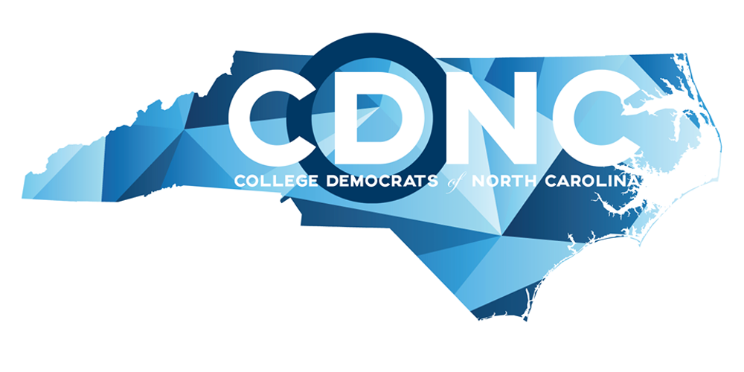 | 

Website Resources

The NCATD’s website is a great place to access information on our organization and resources for chapter leaders. The following list summarizes the pages on our website and how they can best be used:

Home - General information and links to other pages on our website.

Who We Are - Information on current members of the Executive Board.

What We Do - Information on our mission, affiliations, and structure.

Chapters - Information on currently active county chapters in North Carolina.

Events - List of upcoming events sponsored by the NCATD and its affiliates.

Opportunities - List of civic and political opportunities for students.

Register to Vote - List of resources for registering to vote in North Carolina.

Plan of Organization - Link to the current NCATD Plan of Organization.

Leadership Guidebook - Link to the current NCATD Leadership Guidebook

Sample County Bylaws - Link to the sample bylaws for county chapters.

Join the NCATD - Form for becoming an individual member of the NCATD.

Charter a Chapter - Form for chartering a new high school or county chapter.

Contact Us - Form for contacting members of the NCATD Executive Board.

